Boy Scout Troop 633
Christmas Wreaths
Scout Name: ______________________

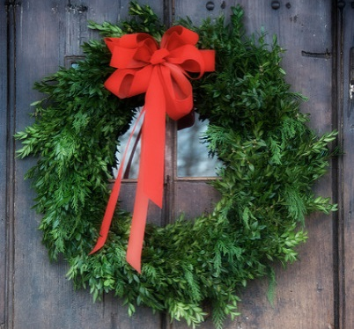
$25
$25

22”-24” Balsam Fir Wreath with Red Bow
Christmas wreaths will be delivered around Thanksgiving weekend
Make checks payable to: Troop 633 /or Troop1633/ or PACK633
RETURN FORM BY OCT 28th meeting
NAME | ADDRESS | PHONE | HOW MANY | AMOUNT | PAID
NAME | ADDRESS | PHONE | HOW MANY | AMOUNT | PAID

NAME | ADDRESS | PHONE | HOW MANY | AMOUNT | PAID

NAME | ADDRESS | PHONE | HOW MANY | AMOUNT | PAID

