**Boy Scout**

**Christmas Wreaths**

Total Wreaths Sold _________

Total Money received $_______

Scout Name: ______________________

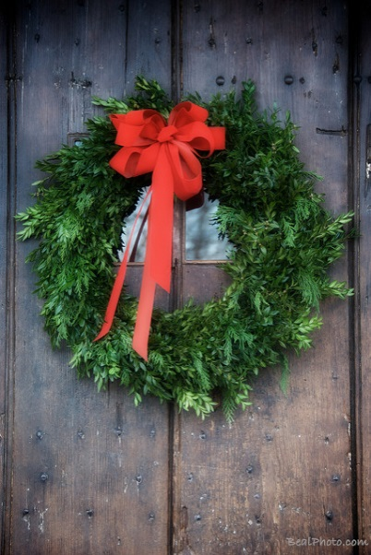

**$25**

**$25**

22” Beautiful Pine Wreath with Red Bow from Vaiuso's Farm

Christmas wreaths will be delivered around Thanksgiving weekend

Make checks payable to: Troop 633 /or Troop 1633/ or Pack 633

All payment is due at time of sale

RETURN FORM BY November 1st meeting

|  |  |  |  |  |  |
| --- | --- | --- | --- | --- | --- |
| **NAME** | **ADDRESS** | **PHONE** | **HOW MANY** | **AMOUNT** | **PAID** |
|  |  |  |  |  |  |
|  |  |
|  |  |  |  |  |  |
|  |  |
|  |  |  |  |  |  |
|  |  |
|  |  |  |  |  |  |
|  |  |
|  |  |  |  |  |  |
|  |  |
| **NAME** | **ADDRESS** | **PHONE** | **HOW MANY** | **AMOUNT** | **PAID** |
|  |  |  |  |  |  |
|  |  |
|  |  |  |  |  |  |
|  |  |
|  |  |  |  |  |  |
|  |  |
|  |  |  |  |  |  |
|  |  |
|  |  |  |  |  |  |
|  |  |
|  |  |  |  |  |  |
|  |  |
|  |  |  |  |  |  |
|  |  |
|  |  |  |  |  |  |
|  |  |
|  |  |  |  |  |  |
|  |  |
|  |  |  |  |  |  |
|  |  |
|  |  |  |  |  |  |
|  |  |

|  |  |  |  |  |  |
| --- | --- | --- | --- | --- | --- |
| **NAME** | **ADDRESS** | **PHONE** | **HOW MANY** | **AMOUNT** | **PAID** |
|  |  |  |  |  |  |
|  |  |
|  |  |  |  |  |  |
|  |  |
|  |  |  |  |  |  |
|  |  |
|  |  |  |  |  |  |
|  |  |
|  |  |  |  |  |  |
|  |  |
|  |  |  |  |  |  |
|  |  |
|  |  |  |  |  |  |
|  |  |
|  |  |  |  |  |  |
|  |  |
|  |  |  |  |  |  |
|  |  |
|  |  |  |  |  |  |
|  |  |
|  |  |  |  |  |  |
|  |  |

|  |  |  |  |  |  |
| --- | --- | --- | --- | --- | --- |
| **NAME** | **ADDRESS** | **PHONE** | **HOW MANY** | **AMOUNT** | **PAID** |
|  |  |  |  |  |  |
|  |  |
|  |  |  |  |  |  |
|  |  |
|  |  |  |  |  |  |
|  |  |
|  |  |  |  |  |  |
|  |  |
|  |  |  |  |  |  |
|  |  |
|  |  |  |  |  |  |
|  |  |
|  |  |  |  |  |  |
|  |  |
|  |  |  |  |  |  |
|  |  |
|  |  |  |  |  |  |
|  |  |
|  |  |  |  |  |  |
|  |  |
|  |  |  |  |  |  |
|  |  |